Have created a table travel using create command and have loaded the datum from TravelData.txt into the table using the load command.

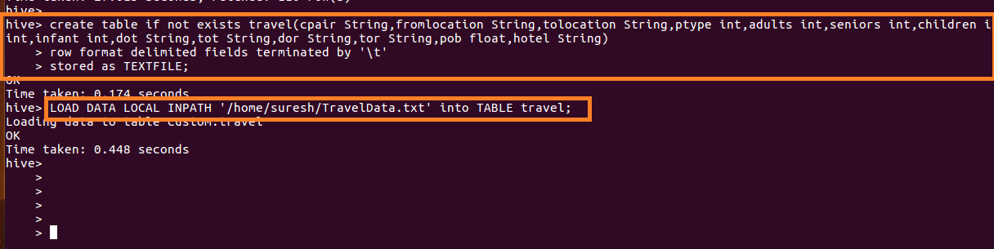

Write a hive query to find the top 20 destination people travel the most

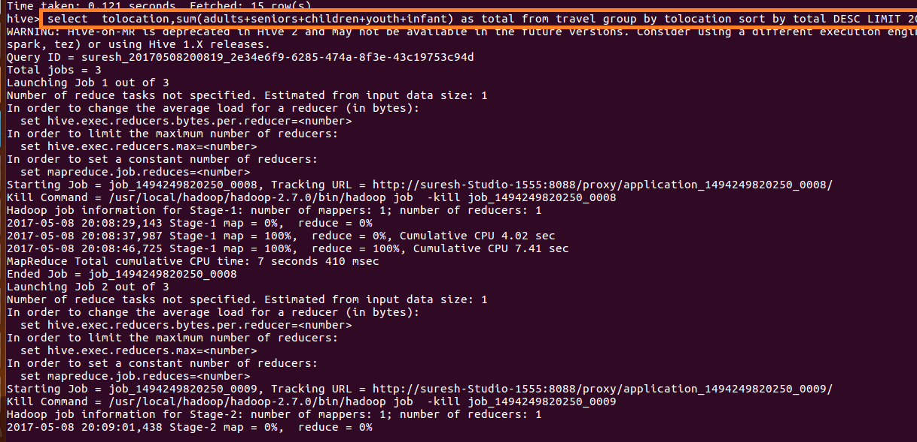

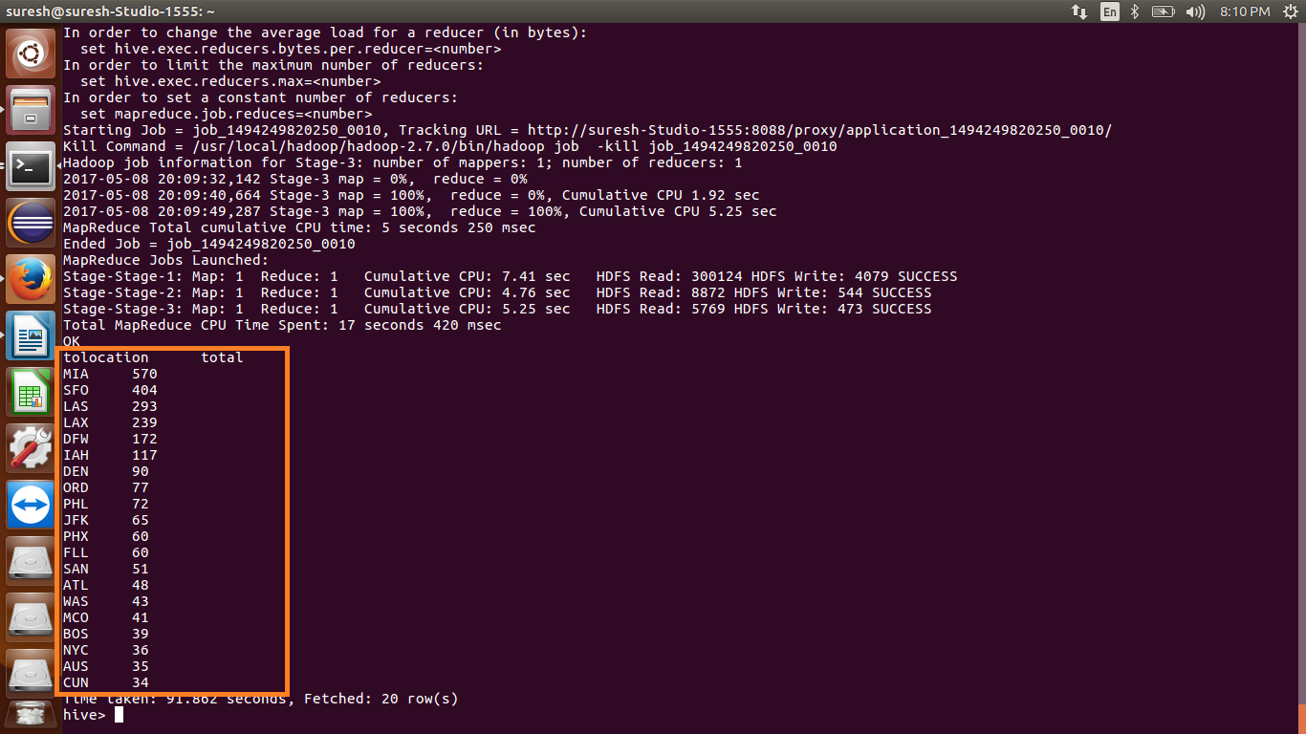

Write a hive query to find the top 20 locations from where people travel the most

